**ETL Project Proposal – CRR – Ryan, Nandini, Steve**

Global Terrorism across multiple years

Base file:

<https://ourworldindata.org/terrorism#data-sources> (180k rows)

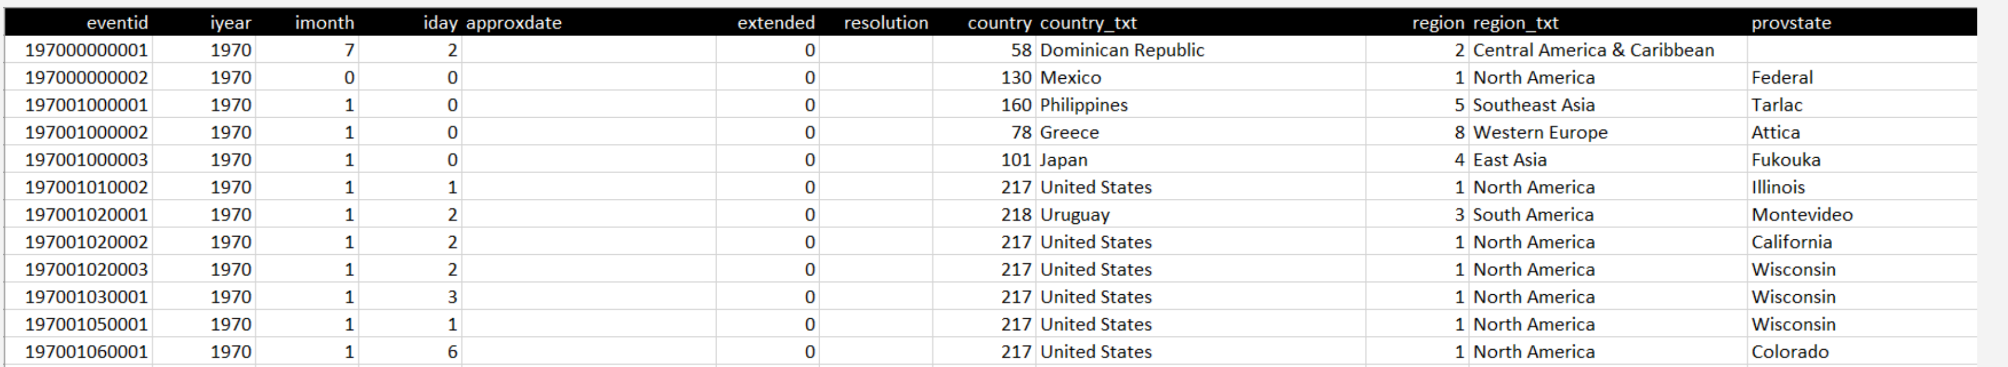

compared to:

Population [https://data.worldbank.org/indicator/sp.pop.totl CSV/EXCEL - 1960-2017](https://data.worldbank.org/indicator/sp.pop.totl%20CSV/EXCEL%20-%201960-2017)

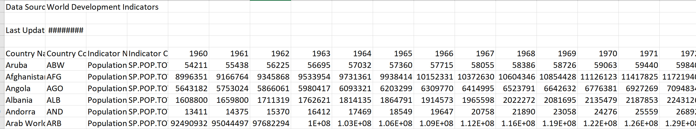

The Worldwide Governance Indicators (WGI)

* *Voice and Accountability*
* *Political Stability and Absence of Violence/Terrorism*
* *Government Effectiveness*
* *Regulatory Quality*
* *Rule of Law*
* *Control of Corruption*

<http://info.worldbank.org/governance/wgi/#home>

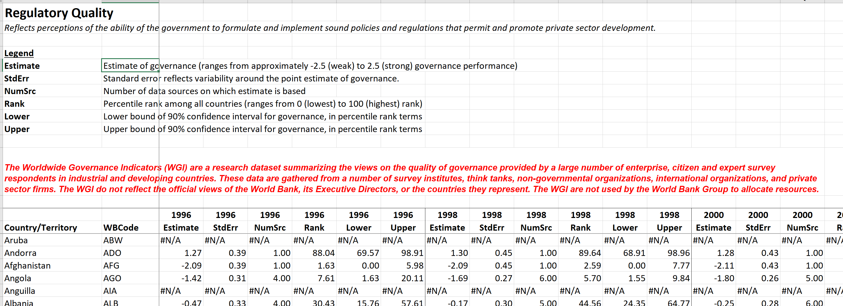

GDP - <https://data.worldbank.org/indicator/ny.gdp.pcap.cd?name_desc=false>

